A Quantitative Test Method for Assessing Color Performance of Endoscopy Devices

Wei-Chung Cheng1*

Quanzeng Wang1

* Correspondence: Wei-Chung.Cheng@fda.hhs.gov

1 Office of Science and Engineering Laboratories, Center for Devices and Radiological Health, US Food and Drug Administration, Silver Spring, Maryland, USA

# Abstract

**Objective:** Endoscopy devices are regulated as medical imaging devices and need to be cleared before being marketed legally. To clear a new endoscopy device, test data is required to demonstrate performance equivalence to a cleared endoscopy device. However, due to the lack of a standard test method for color performance, test results collected with different test methods cannot be compared objectively. To quantitatively compare color performance of different endoscopy devices, bench test methods were developed in this work to characterize and analyze the color characteristics.

**Results:** A flexible endoscope and a capsule endoscope were tested with the described methods. The results show that both devices reduced the chroma and lightness contrast with a pronounced shift in hue with respect to the original target. The color contrast was reduced to 80% and 76% by the capsule endoscope and flexible endoscope, respectively.

**Keywords:** Color performance, endoscopy device, color medical imaging, flexible endoscope, capsule endoscope, colorimetry, color science

# Introduction

Endoscope is a general name for medical imaging devices used to visually examine internal organs via orifices of the human body. For example, a gastroscope can be used to examine the esophagus, stomach, and small bowel via the digestive track. A colonoscope is used to examine the colon and remove polyps through the rectum. A bronchoscope is used to examine the airways through the nose or mouth. More than ten million colonoscopies are conducted in the US every year [1].

An endoscope is a complete imaging system that consists of the light source, camera (including optical lenses and imaging sensor), image processor, and display. The working principle is to project the light and camera into the human body near the area of interest for image acquisition and then transmit the image data out of the human body for image reproduction. For instance, a *flexible endoscope* uses a flexible tube to manually position the camera with lighting while retrieving the image data through electrical conduits in real time [2]. In contrast, a *capsule endoscope* is passively propelled by the gastrointestinal tract and takes images at a much slower rate. The image data is wirelessly sent to an external recorder for offline review [3].

In the US, endoscopy devices are classified as Class II medical devices and regulated by the US Food and Drug Administration [4]. A *premarket notification* needs to be submitted and cleared before a Class II device can be legally marketed. To clear a Class II device, the premarket notification submission needs to include performance test data to show that the subject device is substantially equivalent to at least one legally marketed device, called the *predicate*. As a color medical imaging device, an endoscopy device needs to provide not only optical performance [5] but also color performance test data [6]. Testing color performance is essential because the device characteristics need to be documented for traceability and regulatory purposes. Furthermore, quantitative color performance test data is crucial for devices that claim using hardware or software color enhancement techniques to improve the detection capability. The emerging use of artificial intelligent algorithms to detect lesions also demands consistent color presentation across the images. Color performance tests are usually conducted as bench tests without commissioning clinical or animal studies. However, due to the lack of a standardized color performance test method, performance test data collected with different test methods cannot be compared directly, which impedes establishing substantial equivalence between the subject and predicate devices.

In this paper, we introduce a bench test method for characterizing the color behavior of an endoscopy device and an analysis method for comparing the color performance of different endoscopy devices.

# Main text

## Method for Color Characterization

The workflow of the color performance test method is depicted in Figure 1. The basic idea is to use a color target with known truth to test the device and then compare the device responses with the truth in the standard, device-independent CIELAB color space. Tutorials of basic colorimetry terms such as CIEXYZ, CIELAB, ΔE, reference white, D65, lightness, chroma, and hue can be found in [7][8].



Figure : Workflow of the color performance test for a flexible endoscope.

The upper arm in Figure 1 depicts the imaging chain of a flexible endoscope. A reflective color target with a set of representative color patches is used to test the device. Standard reflective color targets designed for photographic devices are commercially available and widely used for color calibration purposes.

As an imaging system, a flexible endoscope usually consists of three components: the *scope* that illuminates the scene and acquires the image, the *video processor* that includes the hardware and software to generate light, to control the scope and to process/display the image, and a *display* device that reproduces the image. The input to the endoscope system is the optical signals coming from the target, and the output is the optical signals generated by the display. For devices that do not include a display, the output is the digital pixel data sent from the video processor to the display through the display interface (e.g., SDI).

For a capsule endoscope, the component structure is slightly different. Instead of a detachable scope, the *capsule* includes the light source and imaging subsystems. Instead of using a video processor, the imaging data is transferred to the *review workstation* for offline review after the procedure is finished.

The endoscope is tested by imaging the color target illuminated by its built-in light source. A meter (i.e., a colorimeter or a spectroradiometer) is used to measure the optical output in the CIEXYZ color space if a display is included as part of the device.

A *reference white* is required to convert the measured color from the CIEXYZ to the CIELAB color space. The white point of the display (e.g., an 8-bit display driven at RGB=255,255,255) can be used as the reference white. The CIEXYZ values of the color (*X*, *Y*, and *Z*) and the reference white (*Xn*, *Yn*, and *Zn*) are used to calculate the CIELAB values with the following formulas.

()

()

()

()

()

If the device does not include a display, the manufacturer needs to specify the predetermined color space of the display that is expected by the video processor to send pixel data accordingly. In this case, the pixel data needs to be captured on the display interface by a hardware or software tool. Most endoscopes require the display to be calibrated to the standard *sRGB* color space. The pixel values in the sRGB color space (*R*, *G*, and *B*) with the D65 white point can be converted into the CIEXYZ color space (*X*, *Y*, and *Z*) with the following formulas.

()

()

()

()

The lower arm in Figure 1 depicts how the truth of the color target is obtained. Frequently, the color target comes with measurement data provided by the vendor that can be used as the truth after converted into the CIELAB color space. If the color target is out of calibration (e.g., due to fading) or is custom-made, optical measurement with a meter is required to obtain the truth. In this case, a standard, stable light source (e.g., a light booth) should be used to illuminate the target for the meter to obtain the CIEXYZ values. Similarly, a reference white object is required to convert the CIEXYZ into the CIELAB color space. The reference white object should have a flat, near-100% reflectance curve in the visible wavelength (e.g., a reflective white standard or a white balance calibration target included in the device).

The color difference (1976 CIELAB ΔE) between two colors, $L_{1}^{*}a_{1}^{*}b_{1}^{*}$ and $L_{2}^{*}a_{2}^{*}b_{2}^{*}$, can be calculated as follows.

()

## Methods for Data Analysis

The following two methods are recommended for examining the collected CIELAB data. Given the following measurement data collected with the above-mentioned measurement method, let's define

${Truth}_{j}$*:* CIELAB of the *j*-th patch in the test target

${Subject}_{j}$: CIELAB generated by the subject device for the *j*-th patch

${Predicate}_{j}$: CIELAB generated by the predicate device for the *j*-th patch

### Method 1: Color Transformation

The first method visually shows the color transformation as vectors in the three-dimensional CIELAB color space. For each color patch, draw a vector from ${Truth}_{j}$ to ${Subject}_{j}$ to show how the color is reproduced by the subject device. The length of the vector indicates the color difference (*ΔE*), which is useful for evaluating devices that claim to reproduce color faithfully. The direction of the vector indicates how the color is shifted in the CIELAB color space, which is useful for evaluating devices that claim to increase the color difference between two specific colors (e.g., hemoglobin vs. oxyhemoglobin for emphasizing blood vessels). Repeat the same process to draw the vectors for the predicate device for comparison.

### Method 2: Color Contrast

For each pair of patches (*j,k*), calculate the following color differences:

$∆E({Truth}_{j},{Truth}_{k})$: The color difference between the *j*-th and *k*-th patches in the target.

$∆E({Subject}_{j},{Subject}_{k})$: The color difference generated by the subject device between the *j*-th and *k*-th patches.

Define *color contrast enhancement* *(CCE)* between two colors as the ratio of the color difference generated by the subject device to that of the truth.

()

The color contrast enhancement metric predicts whether the color difference between two colors can be preserved by the device. If the CCE is greater than one, the color difference is increased by the device. If the CCE is less than one, the color difference is reduced by the device. If the CCE is one, the color difference remains the same regardless the color transformation may or may not be faithful.

The CCE for the predicate device can be calculated similarly.

()

The CCE values of all pairs ($\frac{n(n-1)}{2}$) of $n$ patches can be analyzed statistically. Alternatively, the color differences of the device vs. the truth can be plotted on the X-Y axes for visualization.

## Results

A flexible endoscope (EVIS EXERA II GIF-H180/CV-180/CLV-180, Olympus America, Center Valley, PA, USA) and a capsule endoscope (PillCam SB3, Covidien USA, Minneapolis, MN, USA) were tested with the proposed methods with a 24-patch target (ColorChecker, X-Rite, Grand Rapids, MI, USA). The color transformation results are presented in Figure 2. For both devices, most vectors point inward in the CIELAB color space. It means that the chroma is reduced by the devices. On the vertical L* axis, the bright colors are lowered while the dark colors are raised. It means that the lightness contrast is reduced by the devices. Neither device preserves the hue very well.

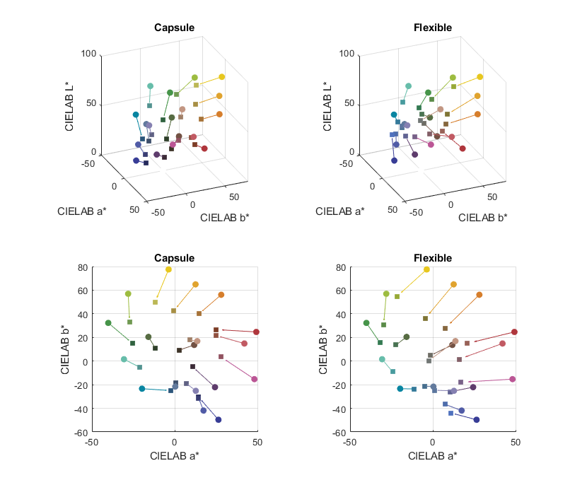

Figure : The 3D (top) and 2D views of the color transformation in the capsule (left) and flexible endoscopes. The circles are the truth colors and the squares are the reproduced colors. Each vector pointing from the circle to the square indicates the color difference.

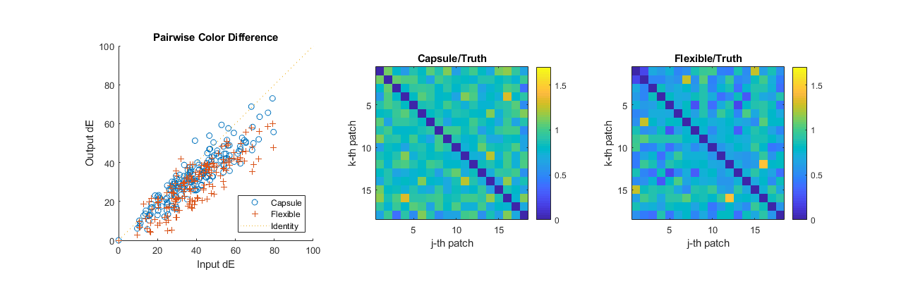

Figure : Comparison of color contrast enhancement for the capsule and flexible endoscopes.

The color contrast results are shown in Figure 3. The relationship between the reproduced color and the truth is shown on left. The mean CCE is 0.80 for the capsule endoscope and 0.76 for the flexible endoscope. The capsule endoscope generated slightly higher color contrast than the flexible endoscope, but both devices generated smaller color contrast than the truth overall. Nevertheless, the result suggested that the color performance of the capsule endoscope was superior. The CCE values of the capsule endoscope are shown in the center plot as a heat map corresponding to color pairs. For example, the highest color contrast (shown in yellow) was generated by the capsule endoscope between the fourth and 14-th patches. Similarly on the right plot, the highest color contrast was between the 12-th and 16-th patches for the flexible endoscope.

## Discussion

In the proposed methods, the device is presumed to have a fixed, global color transformation. Some devices may apply local color enhancement to some features (e.g., edges) or use different color transformation depending on the image content. In those cases, the color performance cannot be characterized by regular methods. It relies on the manufacturer to provide custom test methods to cope with the proprietary color enhancement algorithms.

# Limitations

* The proposed method evaluates only one frame of the video stream, so the test result may not wholly reflect the real-world performance of the endoscopy device if the device does not perform deterministically.
* The spectral reflectance of the standard color target may be different from that of human organs.
* The selection of the color target or color patches may bias the test results.

# Declarations

## Ethics approval and consent to participate

Not applicable.

## Consent for publication

Not applicable.

## Availability of data and material

The measurement data is available at GitHub.

## Competing interests

The mention of commercial products herein is not to be construed as either an actual or implied endorsement of such products by the Department of Health and Human Services.

## Funding

Not applicable.

## Author’s contributions

WCC: Method development. QW: Experiment design.

## Acknowledgements

The authors thank Chih-Lei Wu for collecting the experiment data and Ryan Beams for technical comments.

# References

[1] Seeff, Laura C., et al. "How many endoscopies are performed for colorectal cancer screening? Results from CDC’s survey of endoscopic capacity." Gastroenterology 127.6 (2004): 1670-1677.

[2] Jayne, David. "Johns Hopkins Manual of Gastrointestinal Endoscopic Procedures." *Diseases of the Colon & Rectum* 52.1 (2009): 167.

[3] Iddan, Gavriel, et al. "Wireless capsule endoscopy." *Nature,* 405.6785 (2000): 417.

[4] US Food and Drug Administration. "Premarket Notification 510(k)" https://www.fda.gov/medicaldevices/deviceregulationandguidance/howtomarketyourdevice/premarketsubmissions/premarketnotification510k/default.htm

[5] Wang, Quanzeng, et al. "Development of the local magnification method for quantitative evaluation of endoscope geometric distortion." Journal of biomedical optics 21.5 (2016): 056003.

[6] Vakil, Nimish, Klaus Knyrim, and E. Carr Everbach. "The appreciation of colour in endoscopy." *Bailliere's clinical gastroenterology* 5.1 (1991): 183-188.

[7] Berns, Roy S. Billmeyer and Saltzman's principles of color technology. New York: Wiley, 2000.

[8] Ohta, Noboru, and Alan Robertson. *Colorimetry: fundamentals and applications*. John Wiley & Sons, 2006.